Tony Nammathao

1/22/2020

AME 220

Assignment 1

In order to start off and run an HTML project using the HTTP-server tool, I first needed to install the node.js in order to test out the functions of my HTML file so that I can find what I’m looking for in a clear and constructed format.

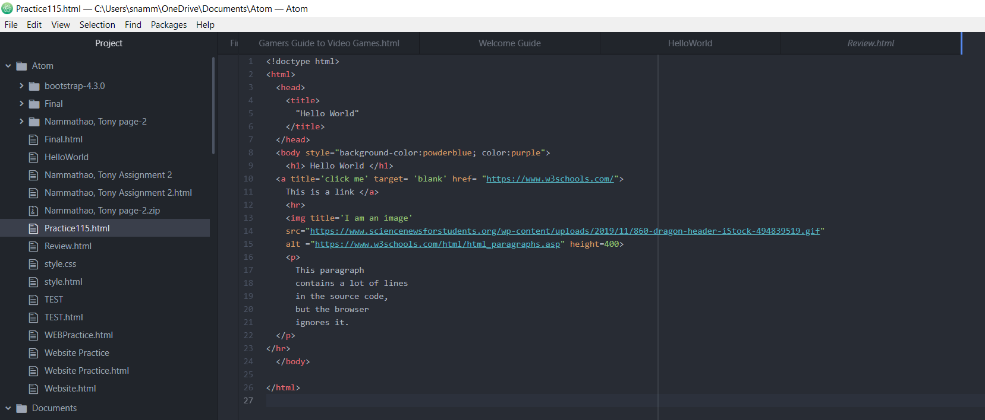

In order to create a properly structured HTML project, I used the Atom program to make a website from scratch using simplistic features that are only filled with the baseline necessities of a website. After editing in Atom the website I am trying to make, I downloaded the Git Bash program so that I would be able to run a cd to my project folder so that it could run the http-server. After saving the project file into an HTML file, the HTML file opened up in the browser to show the website I created in Atom. After finishing up my website, I prepare to import the folder that contains my HTML website file into my Git Bash program in order to transition into my next step.

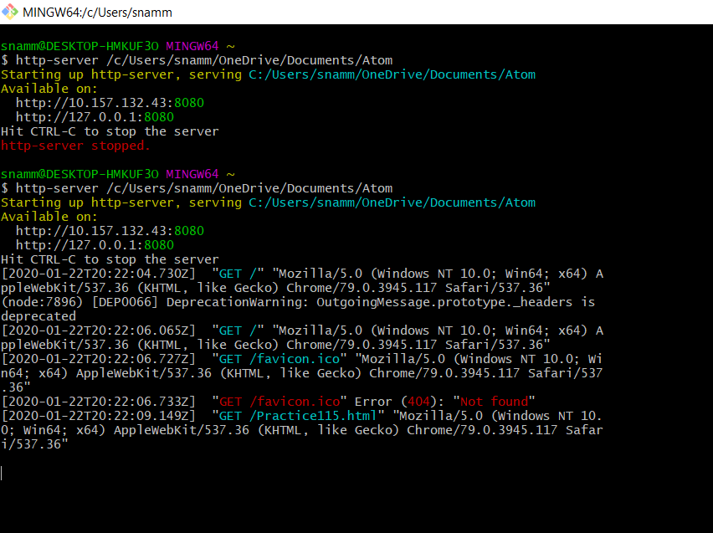

To clarify, I used the HTML file I created in Atom as the groundwork for my Git Bash program to find new possible URLs that were discovered from the result of my HTML file from using the Git Bash program. To find the new URL, I used the command “http-server” and dragging the folder my project is under into the Git Bash program to find the available possible URL that could potentially lead me to the new website created from the HTML file I used to create in Atom. The end result is a new URL that leads me right back to the website that I created from the Atom HTML file with the same specification used to create it. It was through these methods that allow me to find a new URL that can be open in the browser, leading to a simple website without anything excessive.